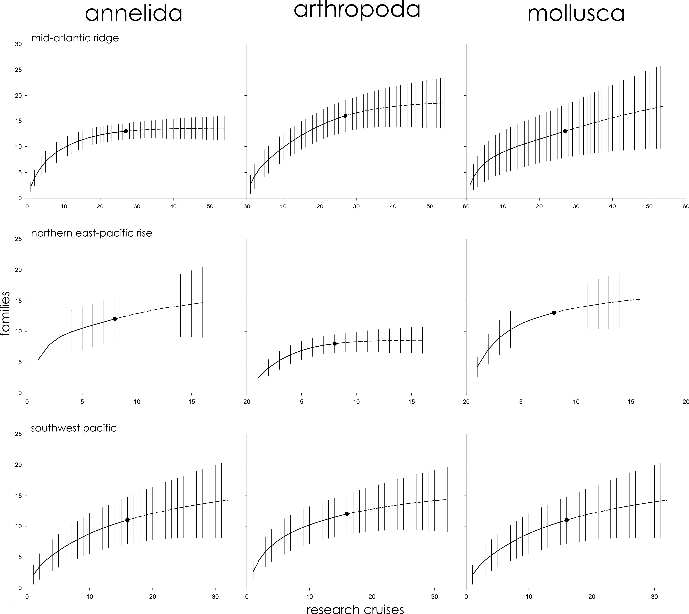

Family richness in the Mid-Atlantic Ridge, Northern East-Pacific Rise, and Southwest Pacific sub-divided by phyla (Annelida, Arthropoda, and Mollusca).
Parametric interpolation (solid line terminating in black dot) and non-parametric asymptotic extrapolation (dashed line) with 95% confidence intervals (vertical black lines).
DOI: 10.7717/peerj.7397/supp-3

Family richness in the Mid-Atlantic Ridge, Northern East-Pacific Rise, and Southwest Pacific for a subset of research cruises ending in 2005 for comparison with ChEssBase.
Parametric interpolation (solid line terminating in black dot) and non-parametric asymptotic extrapolation (dashed line) with 95% confidence intervals (vertical black lines).
DOI: 10.7717/peerj.7397/supp-4
