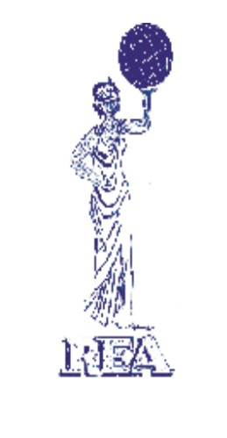
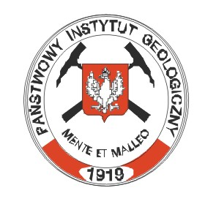
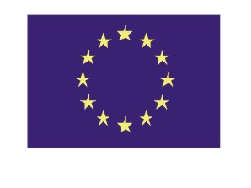
EVK1-CT-2002-80006

Final Announcement and Preliminary Programme

“RELATIVE SEA LEVEL CHANGES
- from subsiding to uplifting coasts”

Conveners:
Svante Björck and Jan Harff

Workshop will be held on June 19-20, 2005 Gdansk
(http://www.pgi.gda.pl/)

Workshop is organized in connection with the 5th Baltic Sea Science Congress

“The Baltic Sea – a changing ecosystem”

to be held at Sopot, Poland 20-24 June 2005,

(http://www.iopan.gda.pl/bssc2005/)

Sponsors and supporting bodies:

- Polish Geological Institute
Centre of Excellence: Research on Abiotic Environment
- INQUA Commission Coastal and Marine Processes
- Baltic Sea Geologists
Scientific Focus

The workshop shall contribute to a better understanding of the complex interrelationships between processes such as land uplift and subsidence, sediment transport, compaction etc. and climate change, and their role as driving forces for relative sea level change. Particularly for the management of coastal systems, different strategies have to be developed for sinking and rising coasts depending on their tectonic settings. The Baltic Sea is exceptional in that it allows studies of both types of coasts in one and the same basin. Therefore, the Baltic plays a key role as a natural laboratory for the investigation of the cause and effect relationship between geosphere, climate and anthropogenic impacts for the development of coastal systems. In order to reconstruct the sea level history at varying geological settings and time periods specific methods have been developed. A combination of data analysis and modelling allows to predict future developments in sea level – and coast-line – change. This predictive potential of geosciences is of special importance for the design and planning the sustainable development of coastal zones. Geologists, palaeoecologists, archaeologists and climate modelers are invited to discuss recent progress and questions within relative sea level change topics during a one day workshop. Oral and poster presentations will provide the background for a scientific discussion that shall bridge between the disciplines in order to deepen the understanding of driving forces and specific behaviour of the change of relative sea level in different geological and tectonic settings. The aim of the cross-disciplinary exchange of ideas is a synergy effect by a better and more holistic understanding of the complex processes of coastal zone development.

The one and half day sessions will be opened by two key-note lectures followed by oral and poster presentations and summarising round table discussion. The Workshop will be also combined with a plenary discussion on current highlights, future scientific developments and creating networks to international research groups.

There is no fee for participation in Workshop and workshop materials.

Workshop materials includes Program and Abstract Book, as well as refreshments at coffee breaks and afternoon barbeque are free for participants.
Participants will have to make their own arrangements for accommodation, lunches and evening meals.

Conference Location
The Conference will be held at Marine Geology Branch of Polish Geological Institute at Gdansk.
address:
Polish Geological Institute, Branch of Marine Geology
Koscierska 5, st., 80-328 Gdansk, Poland
(see enclosed map)

Gdansk can be reached by plane directly or via Warsaw, Copenhagen, Frankfurt, Hamburg and Munich. Train connections Warsaw-Gdansk are hourly. Gdansk can also be reached from Karlskrona and Nynashammferry and from Vilnius and Kaliningrad by bus.

Accommodation
Accommodation for Participants can be reserved by workshop organizers in pensions or in hotels. Hotels in summer season are usually very occupied, so please let us know as soon as possible about your preferential according to location, standard and price of the accommodation

Organizing committee:

Dr. Szymon Uscinowicz and Dr. Joanna Zachowicz
e-mails. szymon.uscinowicz@pgi.gov.pl, joanna.zachowicz@pgi.gov.pl
Secretary: M.Sc. Jakub Zmuda, e-mail: jakub.zmuda@pgi.gov pl
Tel. +48 58 5542909 ext 321, Fax. +48 58 5542910 ext 233

Scientific committee:

Prof. Jan Harff, Baltic Sea Research Institute, Warnemünde, Germany
(jan.harff@io-warnemuende.de)
Prof. Svante Björck, Lund University, Sweden
(svante.bjorck@geol.lu.se)

Conference format

The language used at the conference is English.
Oral presentation: 15-20 minutes, plus 5 minutes of discussion. The conference room will be equipped with a notebook computer with data show, a 35-mm slide projector and an overhead projector.
Poster session: Poster size: 1 x 1.5 metre, 5 minutes for oral presentation of the main ideas presented on each poster.

Proceedings

It is planned to publish the scientific results of the workshop as proceedings of the workshop. Papers submitted during the conference will be published as the proceedings at the end of 2003 in Polish Geological Institute Special Papers.
The manuscript should be submitted to the Organizing Committee during the Workshop June 19-20. 2005.

Scientists who will attend in the Workshop “Relative sea level changes - from subsiding to uplifting coasts” are asked to submit manuscripts of their presentation during the Workshop June 19-20. 2005.
please see ENCLOSED Instructions for Authors

See you in Gdansk !

Workshop
“Relative sea level changes
- from subsiding to uplifting coasts”

June 19-20, 2005, Gdansk

PRELIMINARY PROGRAMME

19June, Sunday

10.00 - 10.10: Opening of the Workshop

10.10 - 11.10: Key lectures

Harff Jan
“Changing sea level at sinking coast – competition between climate change and geological processes”

Svante Björck
“A review of some of the complex issues of the Baltic Sea history - isostatic variability, threshold locations, drainages and up-dammings - where do we go from here?”

Paper presentation

11.10 - 11.30: Kortekaas Marloes, Murray A.S., Snowball I.
“Post-Glacial Development of the Southern Baltic Basin; a chronology based on Optically Stimulated Luminescence dating”.

11.30 - 11.50: Rößler Doreen, Lemke Wolfram
“The littorina transgression in the western Baltic Sea: pathways, timing and possible implications for human settlement”.

11.50 - 12.10: Jan Risberg, Göran Alm and Tomasz Goslar
"Variable isostatic uplift patterns during the Holocene in south-east Sweden, based on high-resolution AMS radiocarbon datings of lake isolations"

12.10 -13,10: Lunch

13.10 - 13.30: Mörner Nils – Axel
“From relative sea level changes to absolute changes in sea level and crustal movements”

13.30 - 13.50: Subetto Dmitry A., Dolukhanov P.M., Ludikova A.V., Sapelko T.V., Kuznetsov D.D., Arslanov Kh.A., Zaitseva G.I.
“The Ladoga-Baltic connection and early human migrations in the Holocene”.

13.50 - 14.10: Porotov Alexey, Klimanov Vladimir
“The climate and sea - level changes in the late Holocene: examples from the Black Sea region”.

14.10 -14.30: Porotov Alexey, Badukova E., Boldyrev Vadim
“The Geomorphologic and archaeologic indicators of late Holocene sea-level change on the coastline of Vistula Lagoon”

14.30 – 14.50: Yuspina Ludmila
“The palynological investigations of the bottom sediments in the core from Arkona Basin
of the Baltic Sea”.

14.50 – 15.20: General discussion

15.20 – 16.20: Poster presentation (and coffee)

Badyukova E.N., Zhindarev L.A., Lykianova S.A., Solovieva G.D.
“Geomorphology of the Vistula Spit”.

Christensen Charlie
“The Littorina Sea shore levels in Denmark”.

Hoffmann Gösta
“Reconstructing the geological past to predict future coastal development? Examples from the SW Baltic Sea”.

Marriner Nick, Morhange Christophe, Pirazzoli Paolo Antonio
“Late Holocene relative sea-level changes and coastal tectonics in southern Lebanon, Eastern Mediterranean”.

Miotk-Szpiganowicz Grazyna, Zachowicz Joanna
“Water level changes in the southern Baltic lagoons in the light of pollen and diatom analyses”

Mörner Nils – Axel
“Paleoseismics and tsunami events within the Baltic”.

Rolandas Radzevicius
“Application of concentration coefficients and factors analysis for geochemical investigation of the superficial sediments of Baltic Sea (Lithuanian water area)”.

Schmedemann Nico, Dietrich H., Hoffmann Gösta
“Numeric decompaction of Holocene sediments”.

Tobolski Kazimierz
“Southern Baltic water level and coast line changes reflected in mires and fosil soils. A case study from the Gardno-Leba Plan”.

Zachowicz Joanna, Kramarska Regina, Miotk-Szpiganowicz Grazyna,
Przezdziecki Piotr, Uscinowicz Szymon
“Bio- Litho- and Seismostratygraphy of the Southern Baltic deposits in the light of critical review of the former data”.

16.30 Barbeque

20 June, Monday

Paper presentation

14.00 -14.20: Jędrysek Mariusz Orion
“Stable isotope indication of seawater/freshwater events: Baltic’s Gotland Deep and Thai mangrove peat profile”.

14.20 -14.40: Bitinas Albertas, Boldyrev Vadim, Damušytė Aldona, Grigienė Alma, Vaikutienė Giedre, Žaromskis Rimas
“Anomalously high level of lagoon sediments in the northern part of Vistula Spit, Kaliningrad region of Russian Federation”.

14.40 -15.00: Miotk-Szpiganowicz Grazyna, Uscinowicz Szymon, Joanna Zachowicz, Bitynas Albertas, Damušytė Aldona
“Barriers and Lagoons of the eastern part of the Gdansk Basin – trans-boundary correlation of the coastal evolution”.

15.00 – 15.30: coffee break

15.30 17.00: Round table discussion:

«Sea level indicators and methods of construction of relative sea level curves»
Introduction remarks: Uscinowicz Szymon

Conveniors: Harff Jan and Svante Björck

Openning ceremony and plenary session of the Baltic Sea Science Congress will be held
in the morning of June 20. (www.iopan.gda.pl/bssc2005)

Instructions for Authors

Papers submitted during the workshop will be published as the proceedings at the end of 2005 in Polish Geological Institute Special Papers.
The manuscript should be submitted to the Organizing Committee during the Conference during the workshop June 19-20, 2005.

Polish Geological Institute Special Papers provide a forum for publication of monographs on different aspects of geology of Poland that are expected to be of international interest. PGI Special Papers publishes both original and review works, occasionally proceedings of international conferences, as well. All manuscripts undergo peer review.
Preparation of text. PGI Special Papers are published in English. Authors are strongly encouraged to submit manuscripts in English. It is expected preliminary, the manuscript should not exceed 10-20 normalized pages, including references, illustrations and tables. One paper copy of manuscript should be submitted to the Workshop Organizers. The author(s) should clearly state their name(s), addresses, phone, fax and e-mail on the manuscript title page.
The manuscript should include an abstract, key words, and references. The manuscript should be printed on one side of A4 paper with a 4 cm left margin and double line-spacing, single column. Paragraphs must be separated by a single blank line, without indentations, right-margin justification and hyphenation. Use a common, plain font e.g. Times New Roman 12 pt., number text pages consecutively. Use SI units only. Citation of references must be placed in parentheses with the author’s last name and year of publication e.g. (Kowalski, 1993). The heading hierarchy, including at most three−four levels, should be indicated in the margin. Figure captions should be prepared on separate sheets. The main body text should not include tables and illustrations.
One diskette should be attached with the text format in MS Word. Please supply the following information with the diskette: author’s name, title of paper. word processing program, drawing program, compression program.
Abstract. The abstract should not exceed 200 words. It should briefly report the methods, results and conclusions contained in the work. The abstract is published both in English and Polish.
Key words. After the abstract, list 5−7 key words that describe the subject matter of the work.
References. References should include positions cited in the text, and in the explanations of figures. References should be listed at the end of the main text alphabetically by senior author. Abbreviations of journals and series according to Geological Bibliography of Poland and to editorial requirements.
Examples:
ALLEN P. A., ALLEN J. R., 1990 — Basin analysis. Principles and applications. Blackwell Scientific Publications. Oxford.
KIERSNOWSKI H., MALISZEWSKA A., 1985 ⎯ Coarse-clastic Rotliegendes sediments of the Siewierz −Olkusz region in the light of new data [Eng. Sum.]. Prz. Geol. 33, 4: 181−192.
MALEC J. , 1993 — Upper Silurian and Lower Devonian in the western Holy Cross Mts. Geol. Quart., 37, 4: 501–524.
POSAMENTIER H. W., JERVEY M. T., VAIL P. R., 1988 — Eustatic controls on clastic deposition, I — conceptual framework. In: Sea-level changes: an integrated approach (eds. C. K.Wilgus et al.). Soc. Econ. Petrol. Miner. Spec. Pub., 42: 109–124.

For books it is necessary to give publisher’s name and place of publication. References in Cyrillic alphabets must be transcribed to Latin alphabet.

Tables. Tables should be prepared as separate files in the MS Word format with a single paper copy, or as camera-ready print-outs (A4 maximum).
Illustrations. Originals of drawings and photographs should be submitted in a camera-ready format, along with one paper copy and, if available, in electronic form. Suitable drawing programs include CorelDraw, Illustrator, and Designer. The maximum publication size of illustrations is 175 x 245 mm. Explanations of graphic elements (map patterns, symbols, etc.) should be included on figures. Where appropriate, all figures (maps, etc.) must have a scale bar.
Illustrations are usually reduced in size for publication; thus, lettering must be large enough to permit reduction of up to 30 or even 50 percent. Photograph prints must be on glossy paper, sharp, with high contrast. Plates should be prepared on a white paperboard in a format of 175 x 245 mm. All illustrations should bear the name(s) of author(s) and figure number written with a soft pencil. The approximate position of text-figures and tables should be indicated in the manuscript margin.
It is possible to publish colour illustrations as well as scanned photographs. Colour illustrations are accepted only in exceptional circumstances.

Manuscripts fulfilling the above editorial requirements will be accepted for publication after a thorough peer-review procedure. A review is submitted to the author to consider and revise the manuscript. It should be return in strictly determined time, otherwise it will change its position in the publication queue. The submitting author of accepted manuscripts will receive a proof-copy which should be returned to the editors within two weeks. Substantial revisions of the work are not accepted at the proof stage.
25 copies of the volume are provided to the corresponding author (or scientific editor) for distribution.

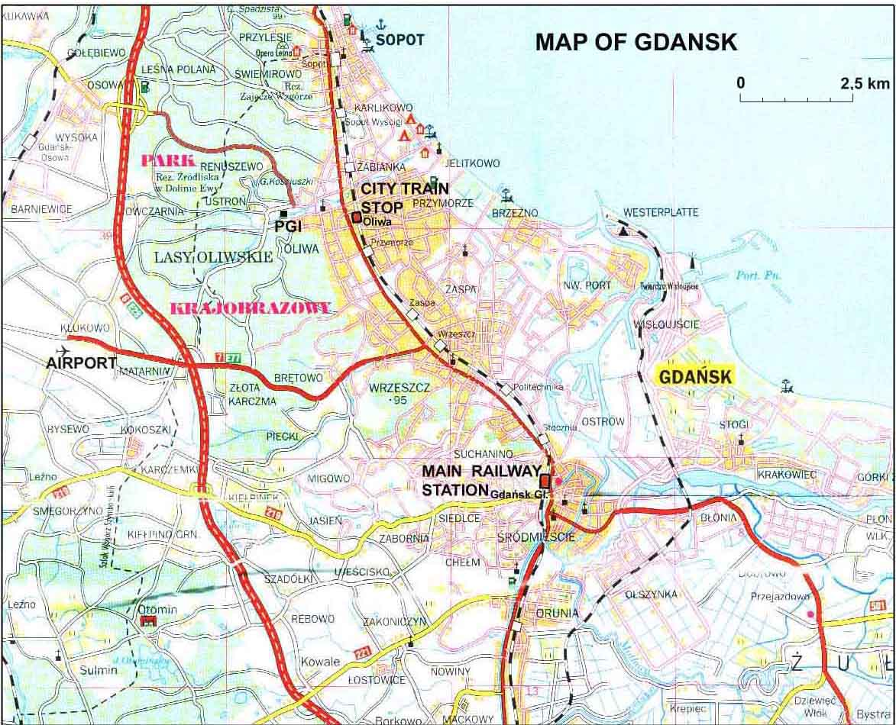

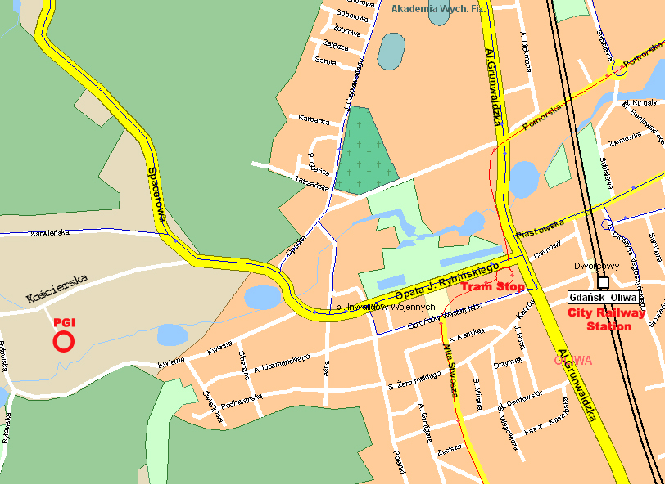
Map of Gdansk-Oliwa and PGI location

